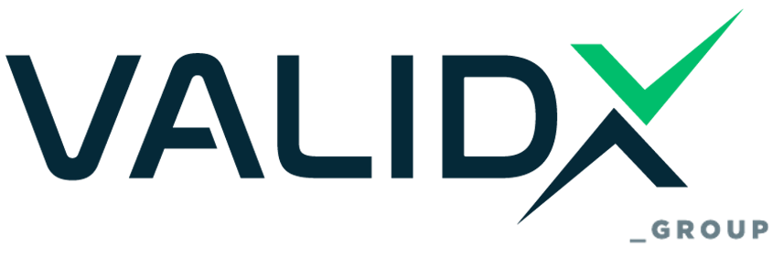

Authorization Regulation under the SERMI Scheme

1. Purpose
This Regulation defines the rules under which VALIDX GROUP, as an ISO/IEC 17020 accredited Conformity Assessment Body (CAB), evaluates, authorizes, monitors, and manages Independent Operators (IOs) and their personnel for access to Security-Related Repair and Maintenance Information (SERMI), in accordance with European legislation and the SERMI Scheme.

2. Scope
This Regulation applies to all applicants (IOs), Responsible Security Staff (RSS), and certified personnel who apply for or hold SERMI authorization issued by VALIDX GROUP.

3. Applicable References
- Regulation (EU) 2018/858
- SERMI Scheme Requirements – SERMI Trust Center
- ISO/IEC 17020:2012
- VALIDX GROUP Procedure D.18 – SERMI Certification Assessment Procedure
- VALIDX GROUP Work Instruction WI.23 – SERMI Certification Inspector Work Instruction
- VALIDX GROUP Forms: F.74, F.75, F.80

4. Eligibility Criteria
To be eligible for SERMI authorization, the applicant shall:
- Demonstrate legal ownership or documented control of an enterprise operating in the automotive repair sector (validated with company documentation and ATECO/NACE activity codes).
- Appoint at least one Responsible Security Staff (RSS).
- Provide clean criminal records for RSS and staff.
- Comply with identity verification requirements (WI.23).
All required documentation must be submitted using:
- Form F.74 – SERMI Inspection Request Form
- Form F.75 – Certification Application Form

5. Application and Assessment Process
VALIDX GROUP will process applications according to:
- Procedure D.18, which defines all evaluation stages including:
  - Review of submitted documentation,
  - Verification of legal status and personnel eligibility,
  - Technical competence review,
  - Identity verification by authorized personnel (WI.23),
  - Issuance of inspection quotation using Form F.80

6. Authorization Validity and Renewal
Authorizations are valid for 5 years, provided:
- Continuous compliance with the SERMI scheme,
- No criminal records or violations reported,
- Updated contact, staff, and legal information is maintained,
- Cooperation during surveillance audits (see WI.23).

7. Rights and Obligations of Authorized Entities
Authorized IOs and RSS personnel must:
- Respect confidentiality of SERMI-related information,
- Use security-related RMI only for legitimate and approved purposes,
- Ensure all staff follow the same requirements outlined in this regulation,
- Maintain updated records, to be reviewed during periodic inspections.

8. Suspension and Withdrawal of Authorization
Authorization may be suspended or withdrawn in the following cases:
- Submission of false or fraudulent information,
- Misuse or unauthorized distribution of security-related RMI,
- Non-cooperation with audits or failure to meet eligibility criteria,
- Any legal or criminal activity incompatible with SERMI access.
VALIDX GROUP will notify the subject in writing, indicating the reason for the suspension/withdrawal. Appeals are managed in accordance with Procedure D.04 – Complaints and Appeals Handling.

9. Complaints and Appeals
All decisions issued by VALIDX GROUP may be contested by the affected party by submitting a formal appeal via:
- Form F.52 – Complaints and Appeals Form
These are handled impartially, according to:
- Procedure D.04 – Complaints and Appeals Handling

10. Confidentiality and Data Protection
All personal and sensitive information collected during the SERMI process is handled under:
- Procedure D.03 – Confidentiality and Information Security
- In accordance with GDPR and relevant national legislation.
Only data required for authorization and communication with the SERMI Trust Center will be processed.

11. Fees and Payments
All applicants shall be informed of costs via:
- Form F.80 – SERMI Quotation Template
Payments are due prior to evaluation. Fees are non-refundable unless otherwise stated.

12. Modifications and Updates
This Regulation may be revised to reflect:
- Changes in European or national law,
- Updates in the SERMI scheme,
- Internal VALIDX GROUP policy adjustments.
Revisions are managed under Procedure D.01 – Document and Record Control. The latest version is always available on the VALIDX GROUP official website.

13. Amendments

Edition | Chapter | Cause & signs of modification | Drafted by | Approved by | Date
v.1 -> v.2 | Overall | Format Change and Group Structure Information Showcasing the relationship with the new entity VALIDX and the IMS Implementation | Athanasios Arvanitis (Quality Manager) | Angelos Koulouridis  Stergios Zarifidis  Sara Pellegrino | 13/05/2025

