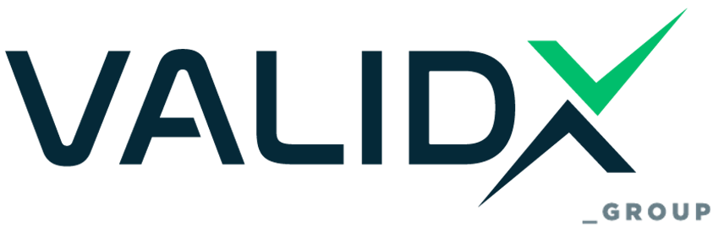

LOGO USAGE REGULATION
(Inspection & Authorization – ISO 17020 / ACCREDIA / SERMI)

1. Purpose
This Regulation establishes the terms and conditions governing the correct and lawful use of the VALIDX & ICDQ PARTNERS logo, accreditation marks (e.g., ACCREDIA), and any associated authorization symbols, including those related to the SERMI scheme. The aim is to prevent misuse, ensure transparency, protect the integrity of accreditation and inspection results, and maintain compliance with ISO/IEC 17020:2012, ACCREDIA Regulation RG-09, and SERMI requirements.

2. Scope
This Regulation applies to:
- All clients and partners of VALIDX & ICDQ PARTNERS who have received inspection reports or certificates,
- Entities authorized under the SERMI scheme,
- Any external organization referring to VALIDX & ICDQ PARTNERS certification or services,
- Internal departments that issue public documents bearing the VALIDX & ICDQ PARTNERS identity.

3. Definitions
- VALIDX & ICDQ PARTNERS Logo: The registered graphic identity of VALIDX & ICDQ PARTNERS used in official documentation and communication.
- Accreditation Mark: The symbol representing VALIDX & ICDQ PARTNERS’s accreditation by ACCREDIA, used only under defined scope and conditions.
- SERMI Reference: Any textual or visual reference to authorization under the SERMI scheme.

4. Permitted Use of the VALIDX & ICDQ PARTNERS Logo
Authorized organizations may use the VALIDX & ICDQ PARTNERS logo only under the following conditions:
- Exclusively in connection with certified or inspected services performed by VALIDX & ICDQ PARTNERS.
- Always accompanied by certificate or report number, clearly indicating the scope.
- On business cards, websites, promotional material, or correspondence only if it does not imply accreditation of the company itself.
The VALIDX & ICDQ PARTNERS logo must:
- Not be altered, distorted, or used in a misleading context.
- Maintain a proportional scale and visual integrity.
- Be displayed with appropriate white space surrounding it.

5. Use of the ACCREDIA Mark
The use of the ACCREDIA accreditation mark must strictly comply with the provisions of:
ACCREDIA REGULATION RG-09 – “Regulation for the use of the ACCREDIA mark”
Clients and authorized entities may only use the ACCREDIA mark under the following rules:
- Only in conjunction with the VALIDX & ICDQ PARTNERS S.r.l. logo, never standalone.
- Only when the inspected activity falls under VALIDX & ICDQ PARTNERS’s accredited scope.
- Must reference VALIDX & ICDQ PARTNERS’s accreditation number and the exact inspection activity performed.
Prohibited uses include:
- Any implication of client accreditation,
- Inclusion on services or scopes outside VALIDX & ICDQ PARTNERS’s accreditation,
- Use after withdrawal or expiration of the report.
Copies of the ACCREDIA RG-09 Regulation are available at: https://www.accredia.it

6. Use of SERMI-Related References
Entities authorized under the SERMI scheme may use wording such as:
“Authorized under the SERMI scheme by VALIDX & ICDQ PARTNERS”
Conditions:
- The reference must relate only to the approved person or workshop (IO/RSS).
- Use must cease upon suspension, withdrawal, or expiration of authorization.
- Use of the SERMI trustmark, logo, or graphic materials is prohibited unless expressly permitted by the SERMI Trust Center.
Any public reference to SERMI status is subject to monitoring by VALIDX & ICDQ PARTNERS and/or the SERMI Trust Center.

7. Prohibited Uses
It is strictly forbidden to:
- Display VALIDX & ICDQ PARTNERS or ACCREDIA logos on uninspected or non-conforming products/services,
- Imply or state that the organization is accredited,
- Use the logo in any way that could mislead customers,
- Use SERMI-related references prior to or after authorization validity,
- Modify or redesign any official mark.

8. Consequences of Misuse
In cases of misuse, VALIDX & ICDQ PARTNERS reserves the right to:
- Issue written warnings,
- Request immediate withdrawal of material,
- Suspend or withdraw inspection certificates or SERMI authorizations,
- Notify ACCREDIA and/or the SERMI Trust Center,
- Take legal action where necessary.

9. Oversight and Monitoring
VALIDX & ICDQ PARTNERS will monitor the use of its logo and associated marks. Random checks and formal reviews will be performed to ensure compliance. Suspected misuse may be investigated without prior notice.

10. References
- ISO/IEC 17020:2012, Clause 7.1.3
- ACCREDIA Regulation RG-09
- SERMI Scheme – Authorization and Communication Guidelines
- VALIDX & ICDQ PARTNERS Procedure D.01 – Document and Record Control
- VALIDX & ICDQ PARTNERS Procedure D.04 – Complaints and Appeals

Note to Users

This Regulation applies exclusively to inspection services and SERMI authorizations falling under VALIDX & ICDQ PARTNERS's accreditation to ISO/IEC 17020. For certified products or processes under ISO/IEC 17065, refer to VALIDX GROUP Regulation GOR.04 – Logo Use Regulation (Product Certification – ISO 17065).

Amendments
Edition | Chapter | Cause & signs of modification | Drafted by | Approved by | Date
v.1 -> v.2 | Overall | Format Change and Group Structure Information Showcasing the relationship with the new entity VALIDX and the IMS Implementation | Athanasios Arvanitis (Quality Manager) | Angelos Koulouridis  Stergios Zarifidis  Sara Pellegrino | 13/05/2025
v. 2 -> v. 3 | Overall | Name change from VALIDX Group to VALIDX & ICDQ Partners | Athanasios Arvanitis  (Quality Manager) | Angelos Koulouridis  Stergios Zarifidis  Sara Pellegrino | 25/06/2025

